Evaluation Development of Strengths (teacher) Name: ________________________ Class: __________ Date: ___________

Theme: ________________________________________________________

You felt : when you: _______________________________________

________________________________________
Happy Afraid Angry Sad Disgusted Surprised

What we did: Goals of the lesson: You showed your strengths in: How did you learn:
 |  | O  O  O  O  Where you can improve:  O  O  O | 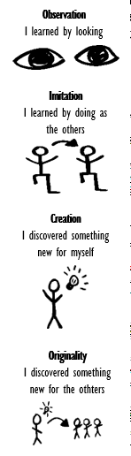

What did I learn? _________________________________________________________________________________________________

Your challenges: __________________________________________________________________________________________________

Where can you improve: ____________________________________________________________________________________________

What do I need? __________________________________________________________________________________________________

What is the next step? ______________________________________________________________________________________________

